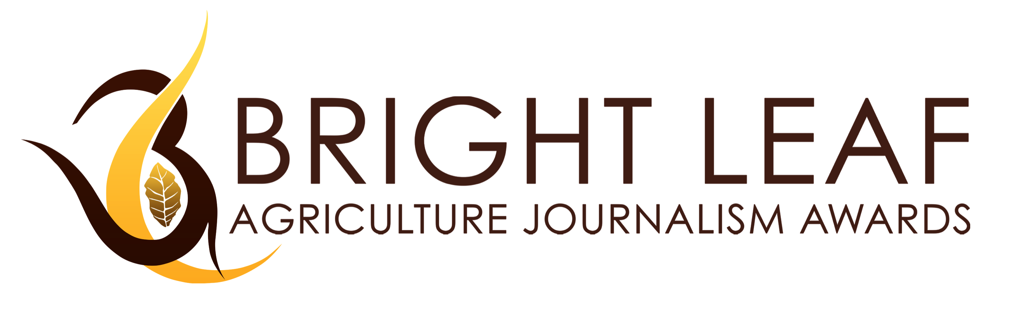
PLEASE MARK WHAT TYPE OF ENTRY YOU ARE SUBMITTING?
PRINT_____ PHOTO_____ ONLINE______ TV_____ RADIO _____
NAME:
ADDRESS:
PHONE:
EMAIL:
DESIGNATION:
TITLE OF ENTRY:

Brief Description:

CATEGORY:
PUBLICATION/BROADCAST DATE:
PUBLICATION/NETWORK/WEBSITE:
TV OR RADIO PROGRAM:
ADDRESS:

CONTACT NUMBER:
EDITOR/PUBLISHER’S NAME:
PHONE:
EMAIL:

I hereby certify that I am the original author/writer/photographer/producer or any other intellectual property output of the material submitted to the Bright Leaf Agriculture Journalism Awards and that I have not plagiarized or copied any other person’s work or intellectual property. In the event that my submission is found to be plagiarized, I shall assume full liability and responsibility for the plagiarism and hold the Bright Leaf organizers free and harmless from any suit, damages or liabilities that may arise. If any judgment is made for plagiarism, I shall indemnify Bright Leaf and the organizers for any and all damages that they may incur. Further, I am allowing Bright Leaf to use my submitted entry or any other intellectual property.
SIGNATURE:

______________________________

